Drew Doty

Course 2 Task 2

Data Science with Python: Working with Credit One Data

Task 2: Prepare and Explore the Data

September 22nd, 2021

**Problem:**

1. Increase in customer default rates – this is bad for Credit One since we approve customers for loans in the first place.
2. Revenue and customer loss for clients and, eventually, loss of clients for Credit One

**Brief:**

How do you ensure that customers can/will pay their loans? Can we do this?

**Exploratory Data Analysis Findings:**

* 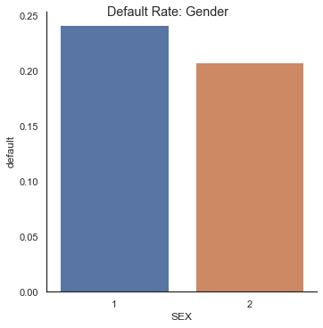Females have a default rate of 20% while males have a default rate of 24%, males are 20% more likely to default than females
* Customers with higher education levels have a lower chance of default

Graduate School: 19%

University: 24%

High School: 25%

* Younger customers have a lower default rate than older customers

20s: 22%

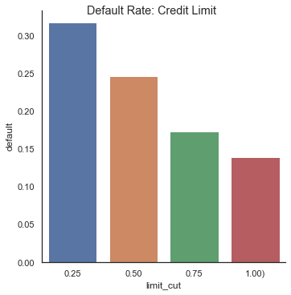30s: 20%

40s: 23%

50s: 25%

60+: 27%

* Customers that are allotted higher credit limits have a lower default rate than customers that are allotted lower credit limits

*Credit One is limiting exposure by limiting customers credit spending, they are allotting high limits customers that are less likely to default.*

0% - 25%: 32%

25% - 50%: 25%

50% - 75%: 17%

75% - 100%: 14%